**CST-256 Design Report Template**

|  |  |  |
| --- | --- | --- |
| **Topic:** | ***Topic 1 Milestone 1*** | |
| **Date:** | ***1/24/2021*** | |
| **Revision:** | ***1.0*** | |
| **Team:** | 1. ***Kayla Currier*** | |
| 1. ***Max Weber*** | |
|  | |
|  | |
| **Weekly Team Status Summary:** | |  |  |  |  | | --- | --- | --- | --- | | **User Story** | **Team**  **Member** | **Hours**  **Worked** | **Hours Remaining** | | ***Home*** | *Max/Kayla* |  |  | | ***Log in/Registration*** | *Max/Kayla* |  |  | | ***Job Listings*** | *Max/Kayla* |  |  | | ***Job Search/Recommended jobs*** | *Max/Kayla* |  |  | | ***My Profile*** | *Max/Kayla* |  |  | |  |  |  |  | |  |  |  |  | |  |  |  |  | |  |  |  |  | |  |  |  |  | |  |  |  |  | |  |  |  |  | |  |  |  |  | | |
| **GIT URL:** | https://github.com/GCUCoding/CST-235 | |
| **Hosting URL:** | *The Hosting URL that I can use to access your application.* | |
| **Peer Review:** | **Y** | We acknowledge that our team has reviewed this report and we agree to the approach we are all taking. |

**Design Documentation**

**Install Instructions:**

*Include step-by-step instructions for setting up your database, configuring, and deploying/installing your application. This section should also include detailed instructions for what configuration files are required by your application, what configuration settings need to be adjusted for various runtime (development or production) environments, and where the files need to be deployed to. This section should also contain detailed instructions for how to clone your application source code from Bitbucket and deploy the application to an externally hosted site.*

***See “GIT URL” for download.***

**General Technical Approach:**

*You should, in words, describe your approach and design here. You should also summarize any meeting notes, brainstorming sessions, etc. that you want to retain through the design of your project.*

***Our plan is to make a social networking site that allows users to post as they would in any social media outlet while also making useful connections with the potential of finding a job based on their skills and personality.***

**Key Technical Design Decisions:**

*Any final technical design decisions, such as framework decisions and so forth., should be documented here. This should list the technology/framework, its purpose in the design, and why it was chosen.*

***We are allowing users to see recent posts on the home page pre-log in and encouraging them to make/sign-in to their account if they want to interact with other users. With an account they will be able to make and personalize their own unique profile by adding a description of themselves, any work or school experience they have, any skills they have that they would like to advertise, their current connections list, and any contact information they want displayed to other users. They will also be able to see local job listings, as well as be able to search for specific jobs.***

**ER Diagram:**

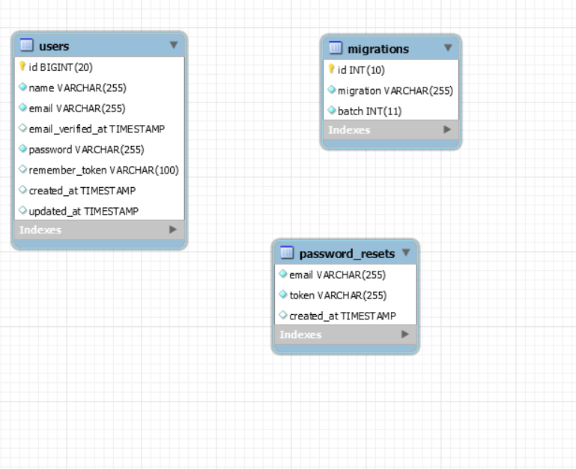

**DDL Scripts:**

*This should contain a link to Bitbucket where the DDL script can be downloaded.*

***networking.sql can be found in the root directory of the Milestone folder***

**Sitemap Diagram:**

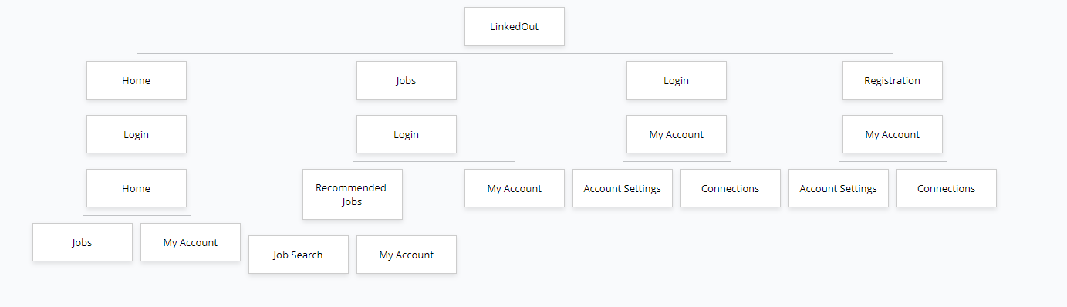

**Security Design:**

*This section should outline the design for how authentication and authorization was supported. This section should also contain all of the roles and privileges that are supported by the design.*

**Third Party Interface Design:**

*This section should fully document any third party service interface APIs, how to access the service, what parameters are required by the API, and the detailed JSON data format specification that could be used by a third-party developer to integrate with the service and API.*

**Flowcharts:**

*Insert any flowcharts here. Flowcharts should document algorithms or workflow that will be implemented in your program. At a minimum, this section should contain a flowchart of your shopping experience.*

**User Interface Diagrams:**

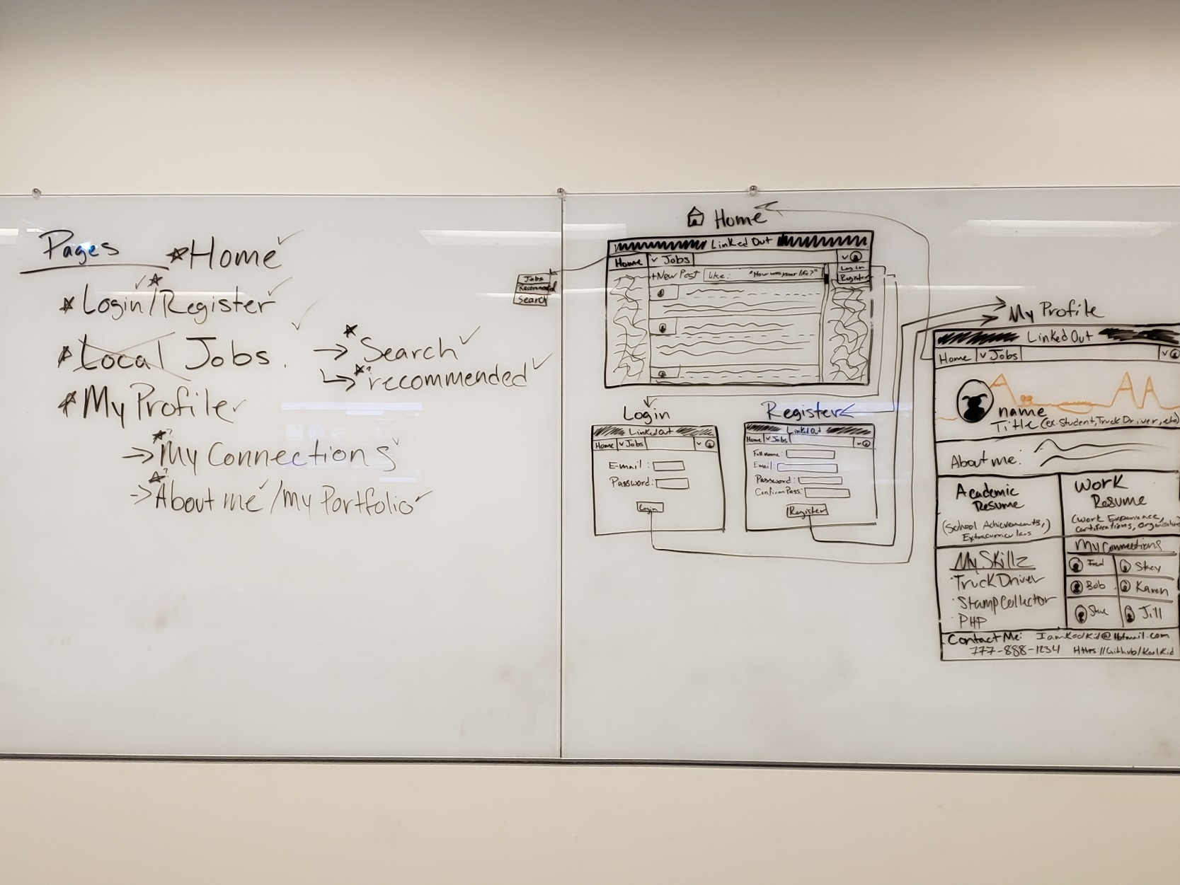

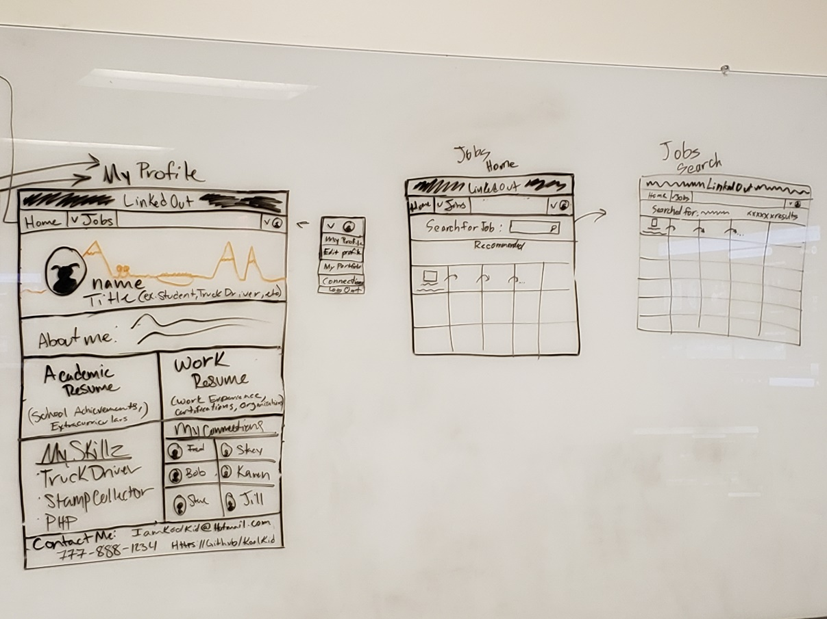

**Class Diagrams:**

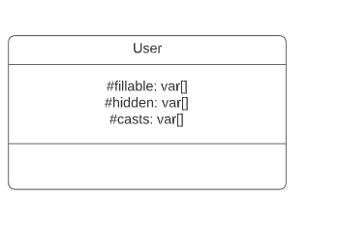

**Pseudo Code:**

*Provide Bitbucket URL references to any code stubs and pseudo code. If you have no supporting documentation, please explain the rationale for leaving this section as N/A.*

**Other Documentation:**

*Insert any additional drawings, storyboards, white board pictures, project schedules, tasks lists, etc. that support your approach, design, and project. If you have no supporting documentation, please explain the rationale for leaving this section as N/A.*